AEM 685 Bo Lin

Question 2

x1=linspace(0,1,40);

x2=linspace(0,1,40);

[X,Y]=meshgrid(x1,x2);

Z = -0.2262\*X .\*Y;

cs=surfc(X,Y,Z);

figure

xlabel('X')

ylabel('Y')

[C1,han1] = contour(X,Y,Z,10,'r-');

clabel(C1,han1);

hold on

Y = -0.5833\*X+1;

plot(X,Y,'r\*')

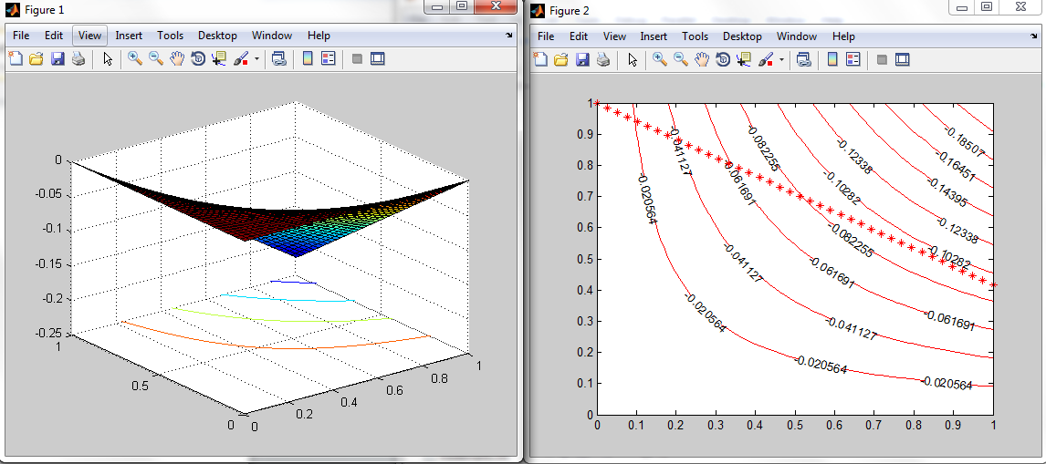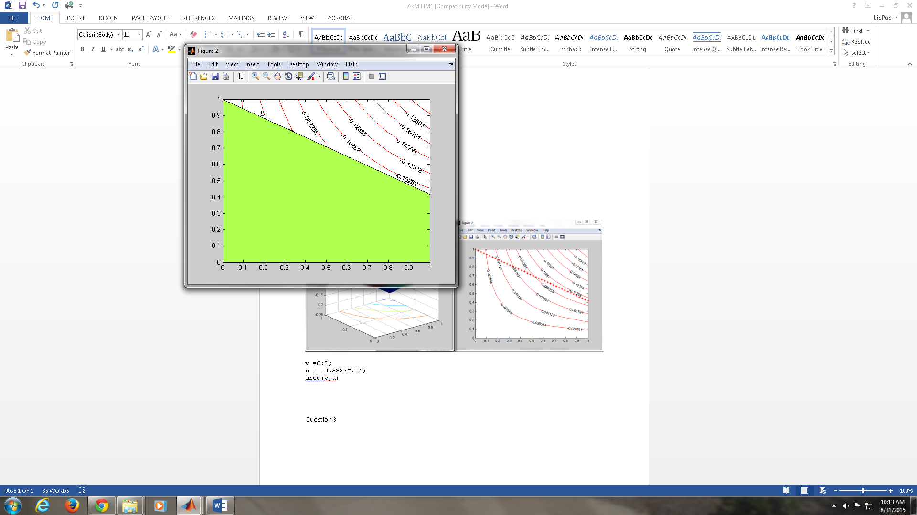

v =0:2;

u = -0.5833\*v+1;

area(v,u)

Question 3

ezplot('-5.6549\*x-1.131\*y+pi\*[(0.18\*x+0.12\*y)\*(0.6\*x+0.36\*y)]^1/2+1.75=0',[0,1])

hold on

ezplot('0.5833\*x+y-1=0',[0,1])

hold on

x1=linspace(0,1,40);

x2=linspace(0,1,40);

[X,Y]=meshgrid(x1,x2);

Z = -0.2262\*X .\*Y;

%cs=surfc(X,Y,Z);

[C1,han1] = contour(X,Y,Z,10,'r-');

clabel(C1,han1);

hold off

